return $this->renderContent(Html::ul( $row

));

}

}

4. Run crypto/test and you will get the following:

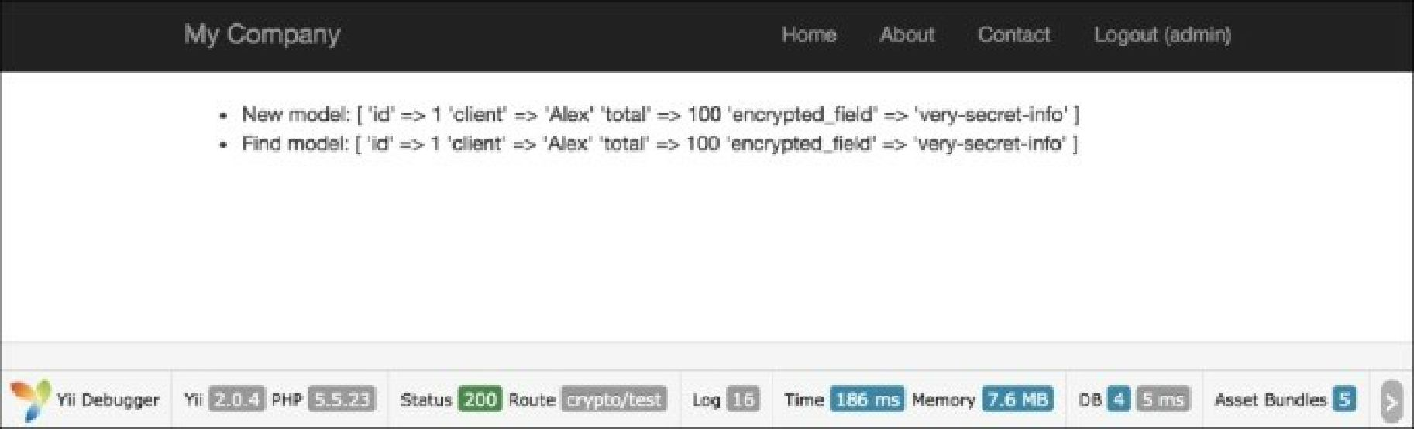

5. To view raw data, run crypto/raw:

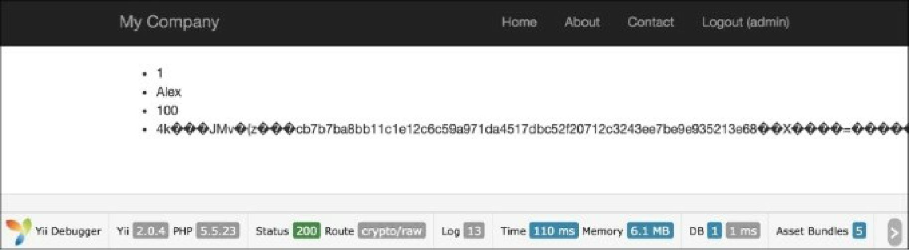

How it works...

Firstly, we have added the AttributeBehavior, which automatically processes our data when certain events happen. Our certain events are ActiveRecord: : event_after_insert,

ActiveRecord::EVENT_AFTER_UPDATE and ActiveRecord::EVENT_AFTER_FIND.

During insert and update events, we decrypt our data with a special method: Yii: : $app->security- >encryptByKey();. This method uses HKDF and a random salt to decrypt our data before saving it to the database. After getting data from the database, we can also use the ActiveRecord: : event_after_find method to decrypt our data. In this case, we also use the special Yii2 method Yii: :$app->security- >encryptByKey(); .This method accepts two params: encrypted data and key.